
Foundation University Islamabad
School of Science and Technology

Name: Hunaina Yasir Roll Number: 073
Subject: PF LAB Section: B
LAB REPORT# 4
Tasks:
4.1 Write a C++ program that takes two numbers from the user and tells which number is greater. Your output should be as below.
Enter the first number: 25
Enter the second number: 32
32 is the greater number.
Second number is greater.

SOURCE CODE:
#include <iostream>
using namespace std;

int main()
{
int a, b;
cout << "Enter 1st number: ";
cin >> a;
cout << "\nEnter 2nd number: ";
cin >> b;

if (a>b)
cout << a <<" is the greater number.";
else
cout << b <<" is the greater number.";

return 0;
}
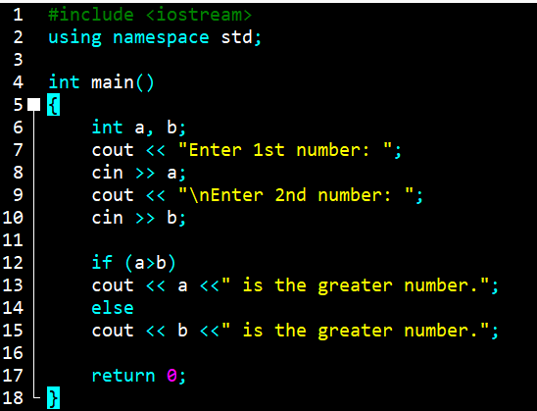
OUTPUT:
Enter 1st number: 23

Enter 2nd number: 45
45 is the greater number.
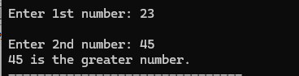

4.2 ‘if/else’ Statement
Write a C++ program that takes five numbers from the user and finds the largest of these numbers. Your output should be as below.
Enter the first number: 25
Enter the second number: 32
Enter the third number: 12
Enter the fourth number: 85
Enter the fifth number : 53
The largest of the 5 numbers is 85.

SOURCE CODE:
#include <iostream>
using namespace std;

int main()
{
int a, b, c, d, e;
cout << "Enter 1st number: ";
cin >> a;
cout << "\nEnter 2nd number: ";
cin >> b;
cout << "\nEnter 3rd number: ";
cin >> c;
cout << "\nEnter 4th number: ";
cin >> d;
cout << "\nEnter 5th number: ";
cin >> e;

if (a>b && a>c && a>d && a>e)
cout << "\nThe largest number is " << a;
else if (b>a && b>c && b>d && b>e)
cout << "\nThe largest number is " << b;
else if (c>a && c>b && c>d && c>e)
cout << "\nThe largest number is " << c;
else if (d>a && d>b && d>c && d>e)
cout << "\nThe largest number is " << d;
else
cout << "\nThe largest number is " << e;

return 0;
}
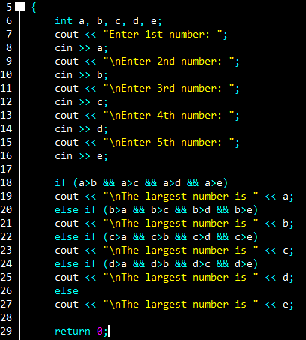
OUTPUT:
Enter 1st number: 6
Enter 2nd number: 8
Enter 3rd number: 5
Enter 4th number: 9
Enter 5th number: 3

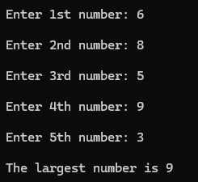
The largest number is 9

4.3 ‘Switch’ Statement
Write a C++ program that performs five basic arithmetic operations (+, -, *, /, %). Your program should prompt the user to enter two integers and one character, where the character variable will indicate the specific arithmetic operation to be performed using switch statements.
Hint: In the following example, 5 and 7 are the two integers and + is the character value entered by the user. Based on the value of this character variable, your program should perform the appropriate arithmetic operation. You have to write this program using both ‘if/else’ and ‘switch’ statements, one by one.
The output of your program must be presentable.
Enter the arithmetic expression to be evaluated:
5
+
7
5 + 7 = 12

SOURCE CODE:
#include <iostream>
using namespace std;

int main()
{
int a, b;
char choice;

cout << "\nEnter first Number: ";
cin >> a;
cout << "\nEnter an arithmetic operator: ";
cin >> choice;
cout << "\nEnter second Number: ";
cin >> b;

switch (choice)
{
case '+':
cout <<"\n" << a << " + " << b << " = " << a+b;
break;

case '-':
cout <<"\n" << a << " - " << b << " = " << a-b;
break;

case '*':
cout <<"\n" << a << " x " << b << " = " << a*b;
break;

case '/':
cout <<"\n" << a << " / " << b << " = " << a/b;
break;

case '%':
cout <<"\n" << a << " % " << b << " = " << a%b;
break;

default:
cout << "Invalid character!";
}

return 0;
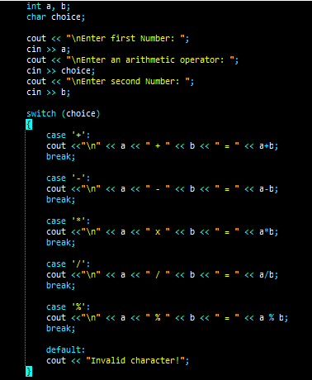
}

OUTPUT:
Enter first Number: 8

Enter an arithmetic operator: +

Enter second Number: 6

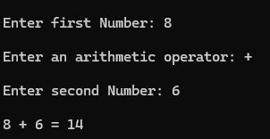
8 + 6 = 14

4.4 Find the error and show the output of the following code.
#include<iostream>
using namespace std;
int main ()
{
int a;
cout<<"enter a";
cin>>a;

int b;
cout<<"enter b";
cin>>b;

char c;
cin>>c;
if(c=='+')
{
cout<<a<<"\n"<<c<<"\n"<<b<<"\n"<<a<<c<<b<<"="<<a+b;
}
else if(c=='-')
{
cout<<a<<"\n"<<c<<"\n"<<b<<"\n"<<a<<c<<b<<"="<<a-b; }
else if(c=='*')
{
cout<<a<<"\n"<<c<<"\n"<<b<<"\n"<<a<<c<<b<<"="<<a*b;
}
else if(c=='%')
{
cout<<a<<"\n"<<c<<"\n"<<"\n"<<a<<c<<b<<"="<<a%b;
}
else if(c=='/')
{
cout<<a<<"\n"<<c<<"\n"<<b<<"\n"<<a<<c<<b<<"="<<a/b;
}
else
{
cout<<"all opertaors";
}
}

ANSWER:
The error in the given code occurs in the modulus (%) condition where the value of b is not displayed on a new line like in the other arithmetic operations. This breaks the consistency of the output format and can confuse the user. Additionally, the program does not clearly tell the user which operator to enter, making the input process unclear and less logical for the user.
If we rewrite the program:
CODE:
#include<iostream>
using namespace std;

int main() {
int a;
cout << "Hunaina Yasir \nRoll number: 073" << endl;
cout<<"Enter first number: ";
cin>>a;

int b;
cout<<"Enter second number: ";
cin>>b;

char c;
cout<<"Enter operator (+ - * / %): ";
cin>>c;

if(c=='+') {
cout<<a<<"\n"<<c<<"\n"<<b<<"\n"<<a<<c<<b<<"="<<a+b;
} else if(c=='-') {
cout<<a<<"\n"<<c<<"\n"<<b<<"\n"<<a<<c<<b<<"="<<a-b;
} else if(c=='*') {
cout<<a<<"\n"<<c<<"\n"<<b<<"\n"<<a<<c<<b<<"="<<a*b;
} else if(c=='%') {
cout<<a<<"\n"<<c<<"\n"<<b<<"\n"<<a<<c<<b<<"="<<a%b;
} else if(c=='/') {
cout<<a<<"\n"<<c<<"\n"<<b<<"\n"<<a<<c<<b<<"="<<a/b;
} else {
cout<<"Invalid operator";
}
}

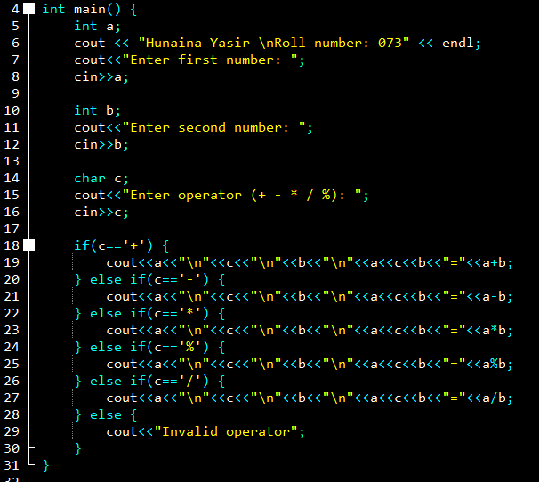
OUTPUT:
Hunaina Yasir
Roll number: 073
Enter first number: 54
Enter second number: 32
Enter operator (+ - * / %): +
54
+
32
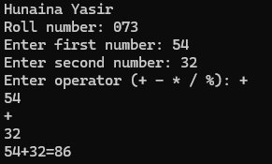
54+32=86

4.5 Find the error and show the output of the following code.
#include<iostream>
using namespace std;
int main()
{
float price,payment,months,payable,newpay,monthins,interest;
cout<<"enter Vehicle price= ";
cin>>price;
cout<<"enter down payments= ";
cin>>payment;
cout<<"enter installment months= ";
cin>>months;
payable=price-payment;
newpay=(payable+(payable*interest));
monthins=newpay/months;
if(months<=12)
{
interest=(10*payable)/100;
cout<<interest;
}
else if(months>=12 && months <=24)
{
interest=(15*payable)/100;
cout<<interest;
}
else if(months<=24 && months>=36)
{
interest=(20*payable)/100;
cout<<interest;
}
else if(months<=36 && months>=48)
{
interest=(100*payable)/10;
cout<<interest;
}
else if(months<=48 && months>=60)
{
interest=30*payable/100;
cout<<interest;
}

cout<<"\nNew Paybale amount= "<<newpay;
cout<<"\nmonthly installment= "<<monthins;
return 0;
}

ANSWER:
The error in the given code is that the variable interest is used in the calculation of newpay before it is assigned any value, which results in an undefined or garbage value being used. Additionally, the conditions for checking the number of months are logically incorrect, such as months<=24 && months>=36 and months<=36 && months>=48, which can never be true at the same time. The interest calculation should be decided first based on the number of months and only then added to the payable amount. Moreover, the program does not clearly guide the user with proper prompts, making it less logical and confusing to understand what inputs are required.
If we rewrite the code again:
CODE:
#include<iostream>
using namespace std;

int main()
{
cout << "Hunaina Yasir \nRoll number: 073" << endl;
float price, payment, months, payable, newpay, monthins, interest;

cout<<"Enter vehicle price: ";
cin>>price;

cout<<"Enter down payment: ";
cin>>payment;

cout<<"Enter number of installment months: ";
cin>>months;

payable = price - payment;

if(months <= 12)
{
interest = (10 * payable) / 100;
} else if(months > 12 && months <= 24)
{
interest = (15 * payable) / 100;
} else if(months > 24 && months <= 36)
{
interest = (20 * payable) / 100;
} else if(months > 36 && months <= 48)
{
interest = (25 * payable) / 100;
} else if(months > 48 && months <= 60)
{
interest = (30 * payable) / 100;
} else
{
interest = 0;
}

newpay = payable + interest;
monthins = newpay / months;

cout<<"Interest amount: "<<interest;
cout<<"\nTotal payable amount: "<<newpay;
cout<<"\nMonthly installment: "<<monthins;

return 0;
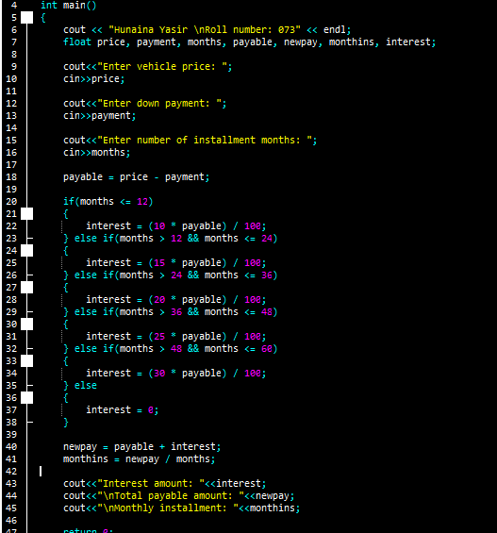
}

OUTPUT:
Hunaina Yasir
Roll number: 073
Enter vehicle price: 50000
Enter down payment: 5000
Enter number of installment months: 2
Interest amount: 4500
Total payable amount: 49500
Monthly installment: 24750

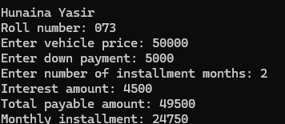

4.6 Find the error and show the output of the following code.
#include <iostream>
using namespace std;
int main()
{
int a;
cout<<"enter the value of a";
cin>>a;
if(a<100&&a>100)
{
cout<<"smaller than 100";
}
else
{
cout<<"greater than 100";
}
if(a==100)
{
cout<<"true equal to 100";
}
}

ANSWER:
The error in the given code is in the condition if(a<100 && a>100) because a number cannot be smaller than 100 and greater than 100 at the same time, so this condition will never be true. Because of this mistake, the program always goes to the else part and prints the wrong result. Also, the logic is not clear for the user because the program does not properly handle the case when the value is exactly 100 in a clear and connected way.
CODE:
#include <iostream>
using namespace std;

int main()
{
cout<<"Hunaina Yasir"<<endl;
cout<<"Roll. number: 073"<<endl;

int a;
cout<<"Enter the value of a: ";
cin>>a;

if(a < 100)
{
cout<<"Smaller than 100"<<endl;
}
else if(a > 100)
{
cout<<"Greater than 100"<<endl;
}
else
{
cout<<"True equal to 100"<<endl;
}

return 0;
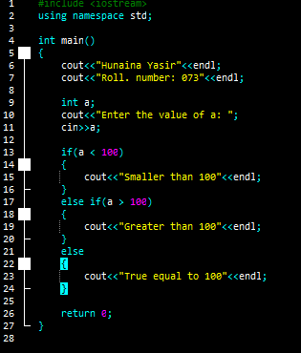
}

OUTPUT:
Hunaina Yasir
Roll. number: 073
Enter the value of a: 34
Smaller than 100

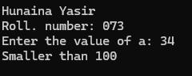
4.7 Write a C++ program that calculates the final price of an item after applying a discount. Prompt the user for the original price and apply a 10% discount if the original price is greater than $100; otherwise, apply a 5% discount.
SOURCE CODE:
#include <iostream>
using namespace std;

int main()
{
cout<<"Hunaina Yasir"<<endl;
cout<<"Roll. number: 073"<<endl;

float price;
cout<<"Enter original price: ";
cin>>price;

float discount;
float finalprice;

if(price > 100)
{
discount = price * 10 / 100;
}
else
{
discount = price * 5 / 100;
}

finalprice = price - discount;

cout<<"Final price after discount: "<<finalprice;

return 0;
}
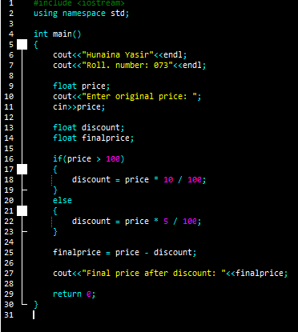
OUTPUT:
Hunaina Yasir
Roll. number: 073
Enter original price: 45000
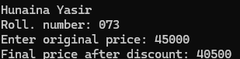
Final price after discount: 40500

4.8 Develop a C++ program that classifies a person into different age groups based on their age. Prompt the user for their age and use if-else statements to categorize them into child, teenager, adult, or senior.
SOURCE CODE:
#include <iostream>
using namespace std;

int main()
{
cout<<"Hunaina Yasir"<<endl;
cout<<"Roll. number: 073"<<endl;

int age;
cout<<"Enter your age: ";
cin>>age;

if(age < 13)
{
cout<<"Child";
}
else if(age >= 13 && age < 20)
{
cout<<"Teenager";
}
else if(age >= 20 && age < 60)
{
cout<<"Adult";
}
else
{
cout<<"Senior";
}

return 0;
}
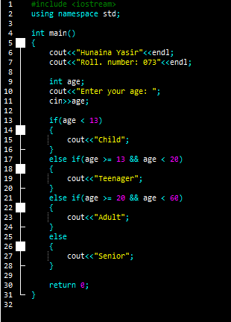
OUTPUT:
Hunaina Yasir
Roll. number: 073
Enter your age: 35
Adult
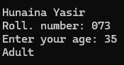
Exercises:
4.1 A shop will give a discount of 10% if the cost of the purchased quantity is more than 1000. How much will you save on your purchase? Please enter the quantity you want to purchase. Assume that one unit costs 100. After you input the quantity, I will calculate the total cost and let you know how much you'll save with a 10% discount if the total cost exceeds 1000.

SOURCE CODE:
#include <iostream>
using namespace std;

int main()
{
cout<<"Hunaina Yasir"<<endl;
cout<<"Roll. number: 073"<<endl;

int quantity;
cout<<"Enter quantity: ";
cin>>quantity;

int totalcost;
totalcost = quantity * 100;

int discount;
int finalcost;

if(totalcost > 1000)
{
discount = totalcost * 10 / 100;
}
else
{
discount = 0;
}

finalcost = totalcost - discount;

cout<<"Total cost: "<<totalcost<<endl;
cout<<"You saved: "<<discount<<endl;
cout<<"Final cost: "<<finalcost;

return 0;
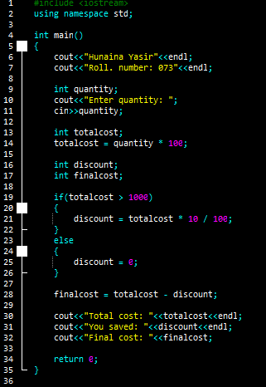
}
OUTPUT:
Hunaina Yasir
Roll. number: 073
Enter quantity: 45
Total cost: 4500
You saved: 450
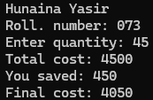
Final cost: 4050

4.2 Find the error and show the output of the following code.
#include <iostream>
using namespace std;
int main() {
double balance = 1000.0;
int choice;
cout << "Welcome to the Simple Bank!" << endl;
while (true) {
cout << "Choose an option:" << endl;
cout << "1. Deposit" << endl;
cout << "2. Withdraw" << endl;
cout << "3. Check Balance" << endl;
cout << "4. Exit" << endl;
cin >> choice;
if (choice == 1) {
double amount;
cout << "Enter the deposit amount: $";
cin >> amount;
balance += amount;
cout << "Deposit successful. Your new balance is: $" << balance << endl;
} else if (choice == 2) {
double amount;
cout << "Enter the withdrawal amount: $";
cin >> amount;
if (amount <= balance) {
balance -= amount;
cout << "Withdrawal successful. Your new balance is: $" << balance << endl;
} else {
cout << "Insufficient funds. Withdrawal canceled." << endl;
}
} else if (choice == 3) {
cout << "Your current balance is: $" << balance << endl;
} else if (choice == 4) {
cout << "Thank you for using the Simple Bank. Goodbye!" << endl;
break;
} else {
cout << "Invalid choice. Please choose a valid option." << endl;
}
}
return 0;
}

ANSWER:
There is no major logical error in this program because it works correctly as a simple banking system. However, for beginners, the use of while(true) can be confusing because it creates an infinite loop and the program only stops when the user chooses option 4. Also, the program does not clearly show the user’s name and roll number before starting the menu, which was required. Apart from these points, the program logic for deposit, withdrawal, balance checking, and exit is correct.

If we rewrite the code again
CODE:
#include <iostream>
using namespace std;

int main()
{
cout<<"Hunaina Yasir"<<endl;
cout<<"Roll. number: 073"<<endl;

double balance = 1000.0;
int choice;

cout<<"Welcome to the Simple Bank!"<<endl;

while(true)
{
cout<<"Choose an option:"<<endl;
cout<<"1. Deposit"<<endl;
cout<<"2. Withdraw"<<endl;
cout<<"3. Check Balance"<<endl;
cout<<"4. Exit"<<endl;

cin>>choice;

if(choice == 1)
{
double amount;
cout<<"Enter deposit amount: ";
cin>>amount;
balance = balance + amount;
cout<<"New balance: "<<balance<<endl;
}
else if(choice == 2)
{
double amount;
cout<<"Enter withdrawal amount: ";
cin>>amount;

if(amount <= balance)
{
balance = balance - amount;
cout<<"New balance: "<<balance<<endl;
}
else
{
cout<<"Insufficient balance"<<endl;
}
}
else if(choice == 3)
{
cout<<"Current balance: "<<balance<<endl;
}
else if(choice == 4)
{
cout<<"Thank you for using the Simple Bank"<<endl;
break;
}
else
{
cout<<"Invalid option"<<endl;
}
}

return 0;
}
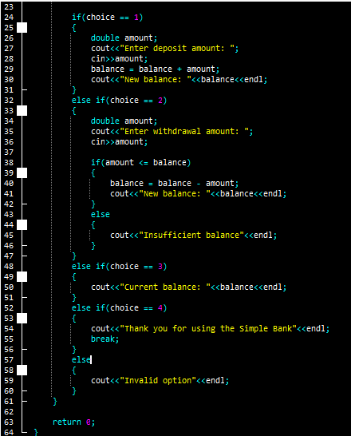
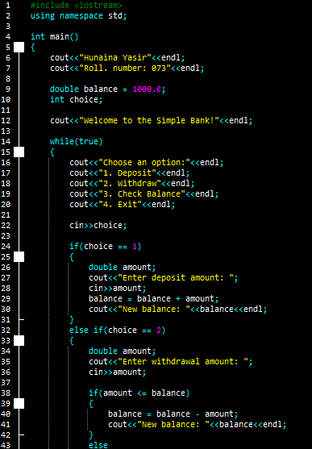
OUTPUT:
Hunaina Yasir
Roll. number: 073
Welcome to the Simple Bank!
Choose an option:
1. Deposit
2. Withdraw
3. Check Balance
4. Exit
3
Current balance: 1000
Choose an option:
1. Deposit
2. Withdraw
3. Check Balance
4. Exit
